THE DEVELOPMENT OF THE RUSSIAN SPACE WEATHER INITIATIVES

A. Dmitriev¹, A. Belov², R. Gorgutsa², V. Ishkov², V. Kozlov³, R. Nymmik¹,
V. Odintsov², A. Petrukovich⁴, G. Popov⁵, E. Romashets², M. Shevchenko⁴, O. Troshichev⁶,
L. Tverskaya¹, A. Zaitzev²

¹Skobeltsyn Institute of Nuclear Physics Moscow State University, Moscow
²Institute of Terrestrial Magnetism, Ionosphere and Radiowave Propagation, Troitsk, Moscow Region
³Yakutian Institute Cosmophysics Investigations and Aeronomy, Yakutsk
⁴Space Research Institute, Moscow
⁵Institute of Solar-Terrestrial Physics, Irkutsk State Academy of Economics, Irkutsk
⁶StPetersburg Arctic and Antarctic Research Institute, Sanct-Petersburg

ABSTRACT

Russian Space Weather Initiatives (RSWI) support different models for space weather forecasting (http://alpha.npi.msu.su/RSWI/rswi.html). The models give the long-time (months-years) and short-time (days) predictions of the solar activity, heliospheric conditions, and dynamics of the Earth's magnetic field and radiation. Many different parameters measured from the Sun to the Earth's magnetosphere are used as inputs to the space weather models. The paper is devoted to a short overview of these models.

Introduction
Russian space weather initiatives (RSWI) began operation one year ago (Avdyushin et al., 1999). RSWI cover many topics from solar activity via interplanetary conditions to the magnetosphere and near Earth's radiation dynamics. Many scientific groups in Russia have research different features of the space weather during two past decades. The wide network of ground based stations performs the measurements of the Earth's magnetic field (magnetometers), solar radio emissions (radio telescopes) and cosmic ray fluxes (neutron monitors). The complex program of near Earth satellite experiments produces in-situ information about the magnetosphere and the radiation environment, plasma characteristics, solar wind and interplanetary magnetic field (IMF). This information is ultimately important for diagnostics of the interplanetary medium and Earth's magnetosphere conditions. Many theoretical and empirical models developed by Russian scientists are used for description and prediction of different types of phenomena in the solar-terrestrial connection. These resources are combined on the RSWI web-site http://alpha.npi.msu.su/RSWI/rswi.html as the list of the links which reflect the main directions of the space weather diagnostics and forecasting: the Sun, solar corona, heliosphere, magnetosphere, near Earth's radiation and space weather prediction.
Several groups took part in the SCOSTEP S-RAMP Space Weather Month Campaign, September 1999. Experimental data and models are collected on-line at www-page http://dec1.npi.msu.su/~dalex/events/iswmc/sept99.htm. Moreover three outstanding space weather storms on April 4-8, May 20-26 and June 6-8 were studied in detail using various data and models by different RSWI groups (http://dec1.npi.msu.su/~dalex/events/events.htm). These examples demonstrate the possibility of different RSWI groups for fast on-line presentation of their scientific results in Internet. The paper is devoted to a description of the resources located in the RSWI web-site and associated with searching for the most important experimental and model parameters that have to be used for space weather diagnostics and forecasting.

Space weather diagnostics
The diagnostics of the space weather is based on on-line information both from active experiments presented in real time and from experimental databases. Comparison analysis of the current observations with previous ones permits the classification of the current space weather conditions and an estimate their possible influence on the Earth's magnetosphere and near Earth radiation. So the diagnostics are a main part of the space weather forecasting.
Sun Observations. IZMIRAN Solar Radio Laboratory (LaRS) supports the solar radio patrol by means of 169 MHz, 204 MHz, 3000 MHz radiometers and 45 - 270 MHz digital spectrograph (http://helios.izmiran.troitsk.ru/lars/LARS.html). Irkutsk Radioastrophysical Observatory (ISTP SD RAS) presents on-line information about optical and radio observations of the Sun (ftp://ssrt.iszf.irk.ru/pub/data) and bursts of solar emission at 5.7GHz (http://rao.iszf.irk.ru/bursts/stat.html). Radio observations provide important information about solar radio bursts (Figure 1) that is often associated (Types II and IV) with coronal mass ejection (CME).
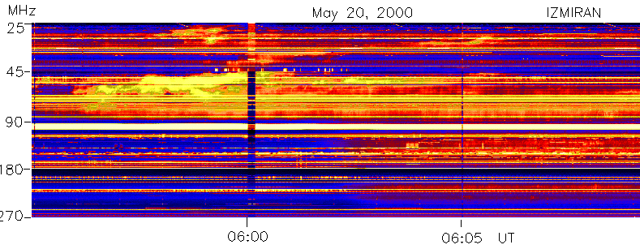
Fig. 1. An example of the II Type solar radio burst in May 20, 2000 (http://helios.izmiran.troitsk.ru/lars/LARS.html)
Galactic cosmic ray observations are presented by the net of several Russian neutron monitors: in Moscow (IZMIRAN http://helios.izmiran.rssi.ru/cosray/main.htm), highest time resolution (10s) monitor in Apatity (PGI http://pgi.kolasc.net.ru/CosmicRay/), Yakutsk and Tixie (IKFIA http://teor.ysn.ru/rswi/graph-GIF.html). Experimental data about cosmic ray variations are loaded into data bases presented on-line on Web-pages http://helios.izmiran.rssi.ru/cosray/main.htm (Moscow), http://pgi.kolasc.net.ru/CosmicRay/form.htm (Apatity) and http://teor.ysn.ru/imf/neutron.htm (Yakutsk and Tixie Bay). Monitoring of GCR variations and scintillation is used for short time (days) prediction (Figure 2) of IMF disturbance (Kozlov et al., 1999; Kozlov 1999) (http://teor.ysn.ru/rswi/graph-GIF.html). GCR scintillation is associated with IMF distortion on the shock boundaries therefore observations of the GCR oscillation permits the discovery of an interplanetary shock when it is still far from the Earth. For quantitative description of GCR variations the hourly index of cosmic ray activity "CR Activity Index" has been introduced (Belov et al., 1999a,b). The simplified version of this index is presented in real time (http://helios.izmiran.rssi.ru/cosray/indices.htm). This index (Figure 3) is developed directly for the purposes of diagnostic and forecasting of interplanetary perturbations and consequent geomagnetic dynamics. GCR variations are very sensitive for the global condition in the inner and outer heliosphere that is problematically determined by in situ measurements on space missions. Fast and deep CGR intensity decreases (Forbush effects) are directly associated with CME reaching to the Earth. Therefore GCR variations may be successfully used for diagnostic and short time prediction of large-scale disturbances (including CME and CIR) in the heliosphere.
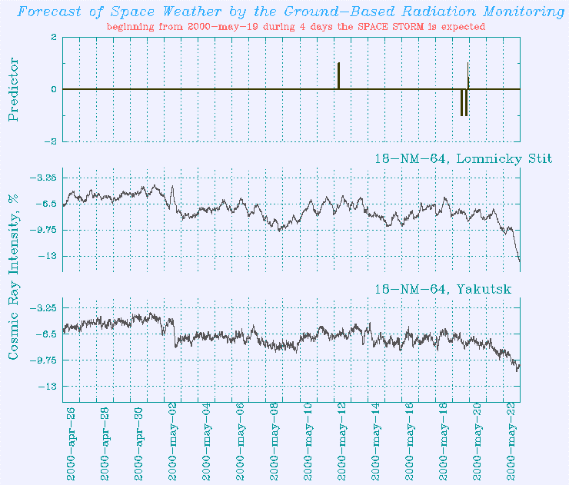
Fig. 2. GCR intensity variations (two lower panels) and cosmic ray scintillation index (upper panel) in May 2000 (see http://teor.ysn.ru/rswi/).
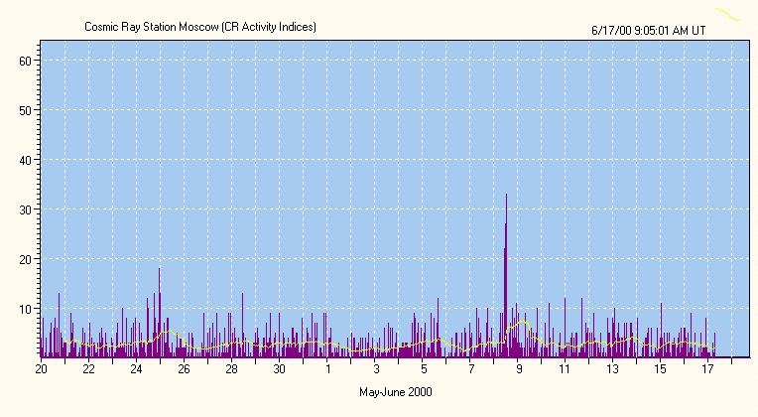
Fig. 3. Dynamics of the cosmic ray activity index in May 2000 (http://helios.izmiran.rssi.ru/cosray/indices.htm).
Earth's magnetic field variations data are coming in real time from Moscow (IZMIRAN http://helios.izmiran.troitsk.ru/cosray/magnet.htm) and Irkutsk (ISTP http://cgm.iszf.irk.ru/magnet2.htm). The databases of the geomagnetic variations are presented on the web-pages http://www.izmiran.rssi.ru/magnetism/mos_data.htm, ftp://vodin.izmiran.rssi.ru/start.htm (IZMIRAN), http://pgi.kolasc.net.ru/Lovozero/ (PGI), http://cgm.iszf.irk.ru/outmag/ (ISTP). The data from the net of Russian geomagnetic observatories are combined on CD-ROM database on ftp-server ftp://vodin.izmiran.rssi.ru/start.htm. The local K-indexes of the geomagnetic activity (Figure 4) are calculated and presented on-line on http://cgm.iszf.irk.ru/magnet2.htm, http://charlamp.izmiran.rssi.ru/ (3 hour indexes in Irkutsk and Moscow respectively). These indexes permit to estimate current geomagnetic activity at the middle geomagnetic latitudes. The other on-line real time geomagnetic PC index is calculated with 1-min resolution via polar cap magnetic field observation (http://www.aari.nw.ru/clgmi/geophys/pc_Data_
Intermagnet.html). Due to specific observational location the PC index is equivalent directly to the energy input from the solar wind to the Earth's magnetosphere (Figure 5).
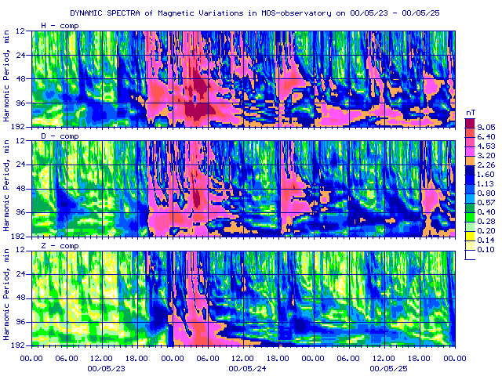
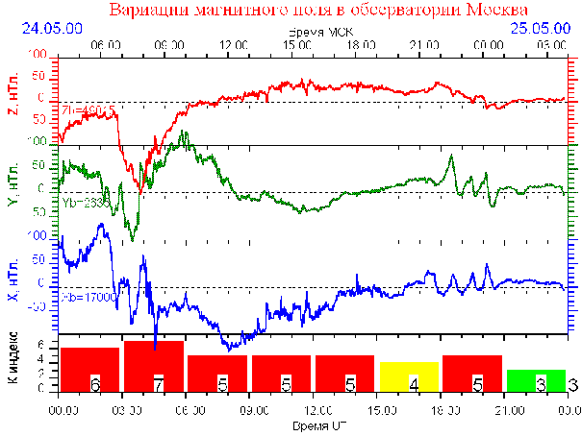
Fig. 4 Geomagnetic field variation and local K-index dynamics in May 2000 (http://www.izmiran.rssi.ru/).
Near Earth's radiation is observed in the space experiments on satellites. The most important parameters for the space weather are fluxes of the penetrating radiation (mainly high-energy ions which include the most part of the radiation dose) and relativistic electrons which produce the internal charge of the satellite. RSWI web-site reflects two main on-line databases of Russian space experiments. IKI Data Archive (http://www.iki.rssi.ru/da.html) contains information about radiation environment from space experiments Prognoz-7, Prognoz-8, Prognoz-9, Prognoz-10, Arcad, Active, Apex, Gamma and Interball. The experimental information includes also the data about x-rays, gamma-rays, plasma properties and magnetic field in the Earth's magnetosphere and in the near Earth's interplanetary medium. Low altitude space radiation environment data base (LASRE) by SINP MSU (http://dec1.npi.msu.su/english/data/lasre/index.html) contains the information about energetic electrons (E>40 keV) and protons (E>0.5 MeV) observed on the near Earth's satellites Intercosmos-19, Cosmos-1686, CORONAS-I and MIR station at altitudes less than 1000 km during the period from 1979 to present. Therefore the LASRE data base permits the study of near Earth radiation dynamics during at least two solar cycles. The real time data about penetrated radiation and gamma-radiation observed in the "Riabina" experiment (Figure 6) permanently operated since autumn of 1990 onboard MIR station is available on web-page http://dec1.npi.msu.su/~rtmir/.
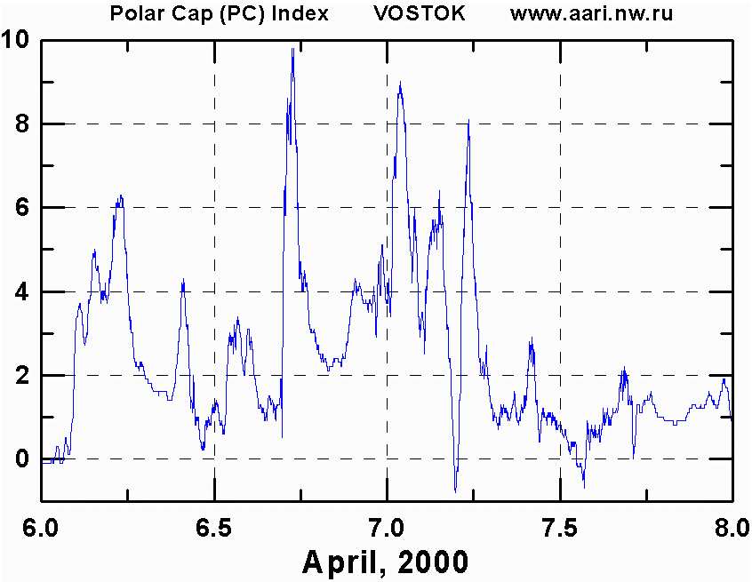
Fig. 5. An example of dynamics of the PC-index of the polar geomagnetic activity (http://www.aari.nw.ru/).
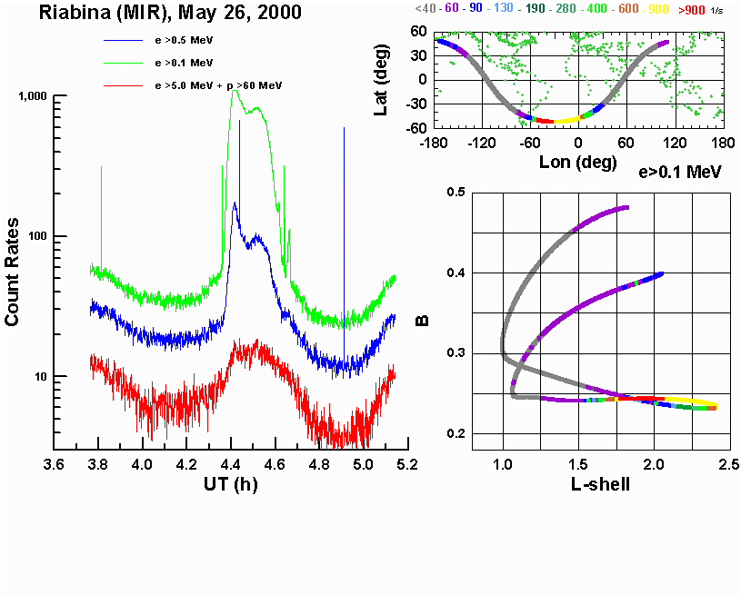
Fig. 6. An example of the penetrated radiation measurements onboard MIR station (Riabina experiment http://dec1.npi.msu.su/~rtmir/)

Nowcasting and forecasting models
RSWI web-site gives details of both long-term and short term forecasting of the space weather events. Long term forecasting (months - years) is based on empirical models of averaged values of different physical parameter depending on solar activity. Short term forecasting (hours - days) is produced by means of dynamical empirical model applications to the current situation determined from the diagnostic of the space weather conditions.
The long-term forecasting models of the key space weather characteristics - solar activity and associated heliospheric and relativistic cosmic ray dynamics - have been developed. Solar cycle parameters are modelled and predicted on the base of the artificial neural network (ANN) technique in SINP MSU (http://dec1.npi.msu.su/~dalex/events/iswmc/sept99.
htm Veselovsky et al., 1999). The solar activity model (Figure 7) permits the prediction of monthly dynamics of yearly means sunspot number W and solar radio flux F10.7 during the current XXIII solar cycle (up to 2005). The ANN model shows that current cycle will be similar to XX solar cycle with maximum in the autumn-winter 1999 and peak mean value W~110. Next solar minimum is expected between 2006-2008. The long-time forecasting of monthly mean solar wind plasma velocity and density and interplanetary magnetic field for period from October 1999 to June 2000 support the conclusion about the similarity of the XX and XXIII solar cycles.
Fig. 7. Solar activity (Wolf number W) forecasting on 1999-2005) (reprinted from (Veselovsky et al., 1999).
The model of the near Earth's radiation has to describe the dynamics of three main kinds of radiation: galactic cosmic rays (GCR), solar cosmic rays (SCR) and trapped radiation. The SINP MSU dynamical model of the GCR is accessible on web-page http://www.npi.msu.su/gcrf/form.html. The GCR model allow the calculation of differential flux of different nuclear types (from H to U) for definite parameters of the near Earth's space mission orbit (Inclination, Perigee, Apogee, Right Ascension of perigee) as a function of solar activity (W) and geomagnetic conditions (Kp-index). Probabilistic model of SCR (SINP MSU http://www.npi.msu.su/scrf/form.html) gives the size of the solar particles fluences and peak fluxes that are expected within a given probability, to be exceeded at a given solar activity level within a given time interval. The improved radiation model based on information system SEREIS (http://dec1.npi.msu.su/~vfb/SEREIS/) is able to describe smoothed variations of energetic particles in the magnetosphere associated with local time, seasonal and solar cycle variations.
Short-time forecasting of the large solar flare and solar geo-effective events (large flare, filament ejection and coronal holes) impacting on the geomagnetic and radiation condition have been developed by V. Ishkov (IZMIRAN http:\\izmiran.rssi.ru\space\solar\forecast.html) and updated weekly. Short-term large flare event forecasting is presently based on observation by the process of new magnetic flux emergencies, its evolution: the magnitude and rate of emergence, its localisation and interaction with already existing magnetic fields of the active region or outside of it. Taking into account physical and geometrical parameters of the flare itself and the active region makes it possible to predict space weather: parameters of the solar proton events, the characteristics of geomagnetic activity and other. The method has successfully tested on Russian scientific satellites such as GRANAT, GAMMA, and CORONAS-I. Computer version of this forecast technique has been developed on the base of real-time solar data (Ishkov 1998; 1999).
The IMF sector structure is continuously restored in the form of the map of the source surface according to original programs of A. Kharshiladze (1994), see page www.geocities.com/romashets/ (Figure 8). The model uses current on-line experimental information about solar and interplanetary magnetic field measurements. IMF sector structure (especially sector boundary location) is extremely important for description of a structure of the heliospheric current sheet and coronal holes (associated with formation of the geoeffective corotation interaction region) and for estimation of the SCR and GCR propagation conditions.
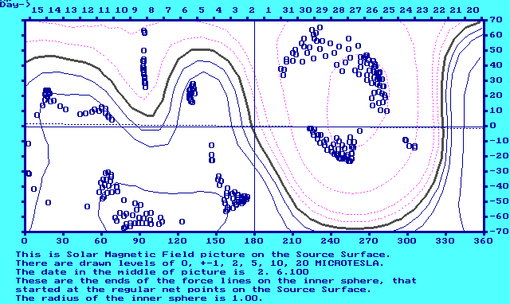
Fig. 8. Sector of space magnetoplasma dynamics in May 2000 (see http://www.geocities.com/romashets/)
3D model of the Earth dayside magnetopause (Figure 9) is accessible on-line on web-page http://dec1.npi.msu.su/~alla/mmp3d/. The model permits to calculate 3D shape and size of the dayside magnetosphere boundary in dependence on the solar wind dynamic pressure and IMF B_{y} and B_{z} components. As shown in (Dmitriev and Suvorova, 2000) the magnetopause shape and size dependence on B_{y} is significant especially under disturbed condition so neglecting of the IMF B_{y} may lead to low accuracy calculation of the dayside magnetosphere properties such as boundary of the trapped radiation region.
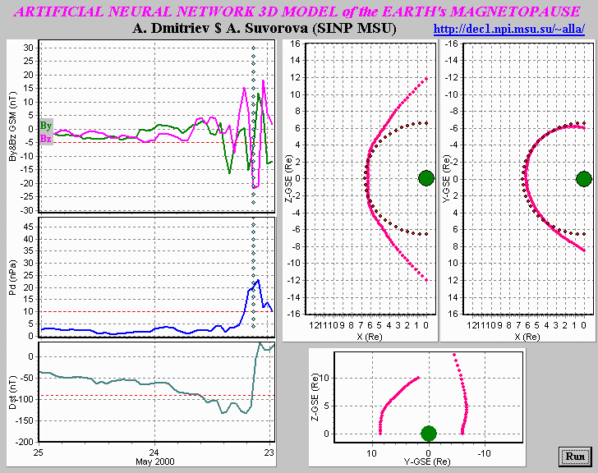
Fig. 9. Dayside magnetopause cross-sections calculated from MPANN code (dec1.npi.msu.su/~alla/mmp3d/)
The short-term prediction of the lowest L-shell position of maximum of storm-injected relativistic electrons of outer radiation belt (L_{max}) in dependence on the maximal Dst-variation of the storm (|Dst|_{max}) is defined by a model of Tverskaya (Tverskaya, 1986): |Dst|_{max}=2.75*10⁴/L⁴_{max}. The dependence permits the prediction of extreme storm-time location of some very important magnetospheric plasma domains such as the extreme latitude of west electrojet center during a storm, boundary of discrete auroral forms, trapped radiation boundary and intensity maximum of symmetrised storm-time ring current (Tverskaya, 2000).
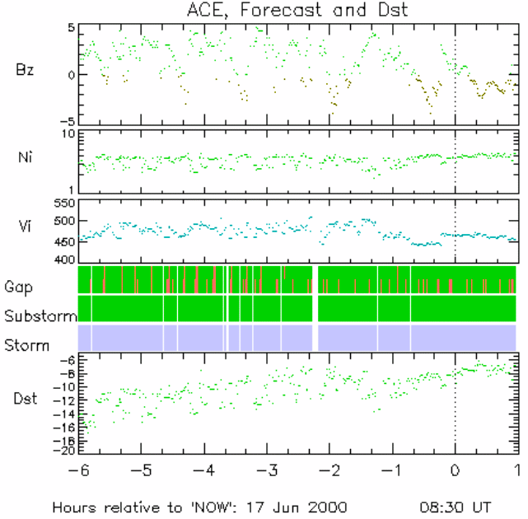
Fig. 10. The short-time (~1 hour) prediction of the Dst-variation using ACE solar wind and IMF data from NOAA/SEC (see http://www.iki.rssi.ru/apetruko/
forecast/forecast.html)
The short-time (~1 hour) prediction of the Dst-variation (Figure 10) is provided by the Space Research Institute using ACE data from NOAA/SEC. Real-time Solar wind and IMF data are shifted by the estimated propagation time, providing along with the Dst-index computation with the use of Burton expression, the electromagnetic energy input in the magnetosphere is estimated. It is used as the qualitative proxy of the substorm and storm geomagnetic activity. Results are presented in graphical form at http://www.iki.rssi.ru/apetruko/
forecast/forecast.html. An extension of the site is underway to provide automatic real-time e-mail alerts estimates of polar cap and auroral oval activity.

DISCUSSION AND CONCLUSIONS
There are many different parameters used for the space weather diagnostics and forecasting. In the paper we describe the most important of them: magnetic flux in the active region on the Sun; type of the solar radio spectrum; Wolf number and solar radio flux F10.7 index; indexes of the cosmic ray scintillation and cosmic ray activity; solar wind pressure and the IMF B_{y} and B_{z} components; indexes of geomagnetic activity Kp, Dst and PC; penetrated radiation fluxes. Some of the parameters can be obtained on-line and frequently in real time from Russian monitoring measurements: solar radio spectrum, cosmic ray indexes, Kp, PC, radiation fluxes. The others (for example Dst-index) can be estimated indirectly via measurements of the solar wind plasma and IMF. But some parameters are not measured in Russia. In this situation the problem of estimation of the space weather parameter importance is significant. The importance of the parameter is determined on the one hand by its possibility to describe one of the space weather properties and on the other hand by convenience of the measurement or calculation of this parameter. Such important parameters as solar radio and electromagnetic emission, solar activity and geomagnetic indexes need patrol measurements by means of a world-wide network of modern detectors. The other space weather parameters (for example cosmic ray indexes and heliospheric parameters) may be measured by means of single detector or by a small net of detectors that is simpler and sometimes cheaper. Beside estimation of the parameter importance is necessary for development of reliable space weather models.
Finally we can conclude that at present time we are on a way to understanding of what parameter and for which purpose has to be applied to describe or predict one or other space weather event in the near Earth's space and on the ground. The comparison of different parameters will be next step for estimation of their capability to adequately describe current or future space weather situation.

References
Avdyushin S., A. Belov, A. Dmitriev, et al., Russian Space Weather Initiatives, Workshop on Space Weather, ESA, ESTEC, 185-198, 1999.
Kozlov V.I., Starodubtsev S.A., Markov V.V. et al., Forecast of Space Weather on the Ground-Based Radiation Monitoring, Proceed. 26 ICRC, 7, 406-109, 1999.
Kozlov V.I., Forecast of Space Weather, Report on SHINE-99, USA, Boulder St. Colorado, 14-19 June 1999.
Belov A.V., E.A. Eroshenko, V.G. Yanke, Indices of cosmic ray activity as reflection of situation in interplanetary medium, Workshop on Space Weather, ESA, ESTEC, 325-328, 1999a.
Belov A.V., E.A. Eroshenko, V.G. Yanke, V.I. Antonova, O.N. Kryakunova, Global and local indices of cosmic ray activity, Proc. 26th ICRC, 6, 472-475, 1999b.
Ishkov V.N., The emergent magnetic fluxes is the key of the large solar flare forecast, Izvestija RAN (ser. Phyzicheskaja), 62, 1835-1839, 1998.
Ishkov V.N., The forecast of geoeffective solar flares: resources and restrictions, Izvestija RAN (ser. Phyzicheskaja), 63, 2148-2151, 1999.
Kharshiladze A.F., K.G.Ivanov, Spherical harmonics analysis of the Sun magnetic field (in Russian), Geomag. i Aeronom., 34, 4, 22-27, 1994.
Dmitriev A.V., and A.V. Suvorova, Artificial neural network model of the dayside magnetopause: physical ponsequences, Phys. Chem. Earth, 25, 1-2, 169-172, 2000.
Veselovsky, I.S., A.V. Dmitriev, Yu.V. Orlov, M.O. Ryazantseva, M.V. Tarsina, Forecasting of the solar activity on 2000-2003 by means of artificial neural networks (in Russian), Proc. of conf. "Large-scale structure of the solar activity: achievements and perspectives", Pulkovo 21-25 June 1999, Snkt-Petersburg, 61-65, 1999.
Tverskaya L.V., On the injection boundary of electrons in the magnetosphere (in Russian), Geomagn. i Aeronom., 26, 864-865, 1986.
Tverskaya L.V., Diagnosing the magnetospheric plasma structures using relativistic electron data, Phys. Chem. Earth, 25, 1-2, 39-42, 2000.

